

**International Institute for Carbon Neutral Energy Research**

**Powering the Future: Economic, Environmental and Social Impacts of I2CNER Initiatives**

**Energy Analysis Division – February 2018**



Contents

Foreword 3

I2CNER Contribution a Low-Carbon Energy Society 4

Section 1 –Science and Energy Technology 5

1 I2CNER Initiatives and Technologies

1.1 Technology Transfer

Section 2 - Environmental Impacts 8

2 I2CNER’s Positive Impact on the Environment

2.1 Greenhouse Gas Reductions

2.2 Featured Technologies

Section 3 – Economic Impacts 11

3 I2CNER’s Impact on the Economy

3.1 Impacts on Employment and GDP

3.2 Featured Technologies

Section 4 – Social and Academic Impacts 14

4 I2CNER’s Impact on Social and Academic Outcomes

4.1 Social Indicators impacted by I2CNER Technologies

4.2 Education and Cultural Exchange

Section 5 – Energy Security 18

5 How I2CNER Contributes to Energy Security

5.1 Technologies Contributing Directly to Energy Security

5.2 I2CNER Technology Initiatives Contributing to Energy Security

Appendix A. Calculation and Estimation Methodology 20

General principles

References

# Foreword

Building on the 2017 report, ‘Toward 2050: Contributing to a Low-Carbon Energy Society’, which details I2CNER’s contribution to CO2 reductions to the year 2050, this report outlines the impacts of I2CNER technologies on the environment, economy, society and energy security in Japan.

Petros’ words here.

# I2CNER Contribution a Low-Carbon Energy Society

This report discusses I2CNER’s contributions within Japan, summarized according to the following categories:

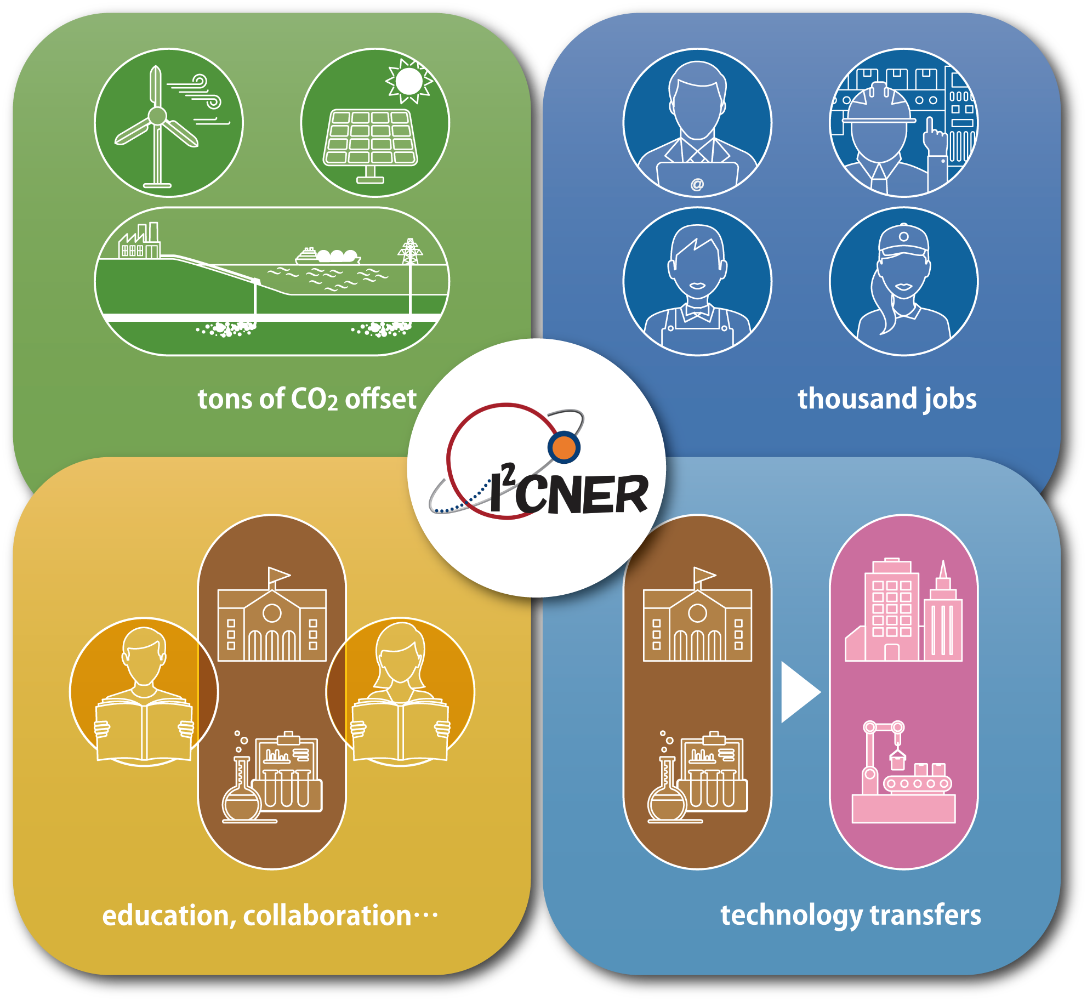

XX

33

63

***Figure: I2CNER’s technologies and research activities impact across the environment, industry, education and outreach, and penetrate the market in order to enable a low-carbon energy transition for Japan to 2050.***

education, collaboration…

X technology transfers…

# Section 1 –Science and Energy Technology

## I2CNER Initiatives and Technologies

I2CNER’s scientific efforts are focused within seven major initiatives, covering renewable

energy, power generation, CO2 capture and storage, energy carriers and storage, energy efficiency, the hydrogen economy and a group of emerging and disruptive technologies. These seven initiatives are summarized in the table below, with examples shown from within each initiative.

|  |  |
| --- | --- |
| **Initiative** | **Technologies** |
| **Renewable Energy** | * Organic-Inorganic Hybrid Perovskite Solar Cell |
| **Power Generation** | * Solid Oxide Fuel Cells (SOFC) * Polymer Electrolyte Fuel Cells (PEFC) * High Efficiency Fossil Fuel Power Generation |
| **CO2 Capture and Storage** | * CO2 Separation Membranes * CO2 Migration Experiments, Modelling and Monitoring |
| **Energy Carriers and Storage** | * Electrolysis * FC-EC Reversible Cell and New Battery Technology * Carbon Neutral Energy Transport and Storage |
| **Energy Efficiency** | * Tribology * Heat Pumps * Heat Loop Tube * Organic Light Emitting Diodes (OLED) * Power Grid and Smart Electricity Systems |
| **The Hydrogen Economy** | * Embrittlement * Low Cost, High Strength Stainless Steels * Transport Sector Design |
| **Emerging and Disruptive Technologies** | * Photocatalytic Water Splitting * Artificial Photosynthesis * Nitrogen Fixation * Direct Air Capture * CO2 Electrochemical Conversion |

Within these initiatives, some technologies are of particular interest for their positive impact on industry and society, their practical applications in a future low carbon society, and also for the exciting innovation that they represent. Section 1.1 outlines the technology transfer events at I2CNER, while section 2 outlines the overall I2CNER contribution to 2050 CO2 reductions, as well as some promising technologies that are currently being developed at I2CNER.

## Technology Transfer

In addition to the innovation and scientific progress within I2CNER, considerable effort is also made to ensure that new technologies can be introduced to the market, often through technology transfer events. As of August 2017, within I2CNER, 33 such events have occurred, and four examples are summarized below.

***Innovative CCS monitoring system in cooperation with Japan Oil, Gas and Metals National Corporation (JOGMEC)***

The continuous monitoring system was developed by I2CNER’s CO2 Storage group lead by Professor Tsuji (Ikeda et al. 2015). This system has been deployed to an active CO2 storage site in Saskatchewan, Canada (the Aquistore CCS project). The collaboration is continuing, with the company funding the research team’s analysis of the recorded monitoring data, toward tracking the migration of CO2 injected 3.4 km underground.

***Novel ceramic-based water electrolysis in cooperation with the Japan Aerospace Agency (JAXA) and Kyocera Group***

Lead by PI Professor Matsumoto and Yuki Terayama, the Electrochemical Energy Conversion Division have been working on a ceramic-based water electrolysis with a unique feature: the ability to operate in “zero gravity”, and therefore be useful in space where gravity is low, and the oxygen regenerated by water electrolysis would help generate a breathable atmosphere. We are collaborating with the Japan Aerospace Agency (JAXA) under the national CREST project to develop this application. This electrolysis cell can also be applicable to energy storage, and the researchers are working with Kyocera Corp towards commercializing this application aspect.

***Development of novel metal packaging for sealing 100MPa hydrogen gas in cooperation with TOKi engineering***

Reliable gas seals are one of the most important and fundamental components for the safety of high-pressure hydrogen containment systems. Various types of seals have been applied; however, a new I2CNER packing is superior to existing products in terms of leak rates, workability, price, delivery, reuse, etc – developed by Professor Kubota in the Hydrogen Materials Compatibility Division. This packing can enable the deployment of high-pressure hydrogen containment systems by reducing cost and increasing reliability. The packing features a unique self-tightening mechanism, which was verified by TOKi and the National Institue of Advanced Industrial Science and Technology (AIST). However, the detailed design of the packing was quite nuanced to achieve the reliability required for commercialization. I2CNER-related research informed the structural design and materials selection for successful commercialization of the product (HYDROBLOCKER). The key research results were on fretting wear and fatigue crack initiation, and the effect of hydrogen on these failures. TOKi engineering continues to fund the project for an additional three years for the development of a packing for liquid hydrogen service.

***Hydrogen refueling station deployment analysis in cooperation with Toyota Motor Corporation and the Ministry of Economy, Trade and Industry (METI)***

Since 2014, the Energy Analysis Division, led by Professor Itaoka has conducted research on the deployment of hydrogen refueling stations in collaboration with, and with funding from, Toyota Motor Corporation. The goal has been to provide the government and stakeholders with information necessary for the efficient deployment of hydrogen refueling infrastructure. This analysis has informed government policy on the appropriate number and location for the initial deployment of hydrogen refueling stations which can usher in the hydrogen economy in Japan.

# Section 2 - Environmental Impacts

## I2CNER’s Positive Impact on the Environment

I2CNER will play a major role in the achievement of a low-carbon society by 2050. This section outlines the impact of our current and future achievements on reaching a 70% carbon reduction by 2050. This major goal will be met through a combination of implementing promising energy technologies which are poised to or already achieving market share and through major achievements in basic science to deliver emerging, disruptive technologies which could revolutionize the energy transition.

## Greenhouse Gas Reductions

I2CNER’s contribution to the 70% CO2 reduction target is divided into the 7 initiatives, as detailed in section 1. Below is a summary of the projected I2CNER contribution to the overall 2050 CO2 reduction target, and our current contribution as at the end of 2017. Details of these reductions can be found in the I2CNER publication entitled: Toward 2050: Contributing to a Low-Carbon Energy Society.

|  |  |
| --- | --- |
|  |  |
| Current and Future Contributions | Overall Contributions to 2050 CO2 Reduction Target |

As at the end of 2017, I2CNER’s estimated contribution to CO2 reduction is 0.41%, with a further 4.75% anticipated by 2050. The largest contribution comes from the Energy Storage and Carriers initiative, including innovations such as carbon neutral energy transport and storage and the reversible fuel-cell, electrolysis-cell (FC-EC) battery. In addition to the direct contributions of I2CNER technologies, I2CNER’s research underpins or contributes to a further CO2 reduction of 34.98% by 2050. Notable among these contributions is the Hydrogen Economy initiative, where steel piping, critical to hydrogen economy infrastructure developed at I2CNER makes a direct contribution of 0.12% based on cost, underpins a further 12% whole-industry based contribution including the deployment of hydrogen refueling stations, pipelines and fuel cell vehicles (FCV).

## Featured Technologies

***Low-Cost, High Strength Stainless Steels.***

To usher in the hydrogen economy, hydrogen resistant materials are required to be developed. I2CNER is focusing on designing cost competitive materials for use in hydrogen applications including piping for domestic hydrogen production, transportation and storage in hydrogen stations. The end use of these materials, specifically hydrogen piping, range from fuel cell vehicles, hydrogen power stations and hydrogen boiler applications. The research goals include quantifying fatigue limits for austentic stainless steel up to an 800MPa yield strength with a reduced weight by 2030, enabling the development of compatible, cost-effective materials for use in the hydrogen economy. An additional research goal is to develop hydrogen compatible welds for these austentic stainless steels. The realization of these ultimate goals, and the penetration of I2CNER hydrogen materials into the market, underpin a 12% CO2 reduction in Japan by 2050.

**Figure** **(Image required from division)**

***Carbon Neutral Energy Transport and Storage***

Energy transport and storage are critical to a low carbon, highly efficient energy system for Japan, where deployment potential of renewable energy sources is less feasible than in other nations which have excess land and superior renewable resources. To take advantage of these resources, and to capitalize on the development of selective electrooxidation catalysts and efficient reduction catalysts, several carbon neutral power cycles are envisaged. Two such pathways are the regeneration of alcohol fuel by electro-reduction at greater that 95% Faradaic efficiency and the first circulation of electric power using an alcohol and carboxylic acid coupling which is CO2 emission free. Since alcohol is a liquid at room temperature, it is easy to handle. Conventional container to store and carry it can be used. These advances will lead to electricity storage technologies and specific pathways for liquid energy storage. These technologies are in competition with other energy storage technologies and are expected to be used in fit-for-purpose scenarios.

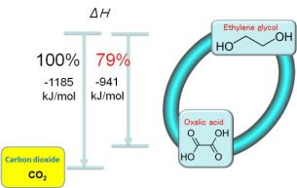

***Figure: Carbon-neutral energy cycle system using ethylene glycol.***

***Artificial Photosynthesis***

Artificial photosynthesis is a technology which produces hydrocarbons (solar fuel) from CO2 captured from the atmosphere, and from water using sun light. Water splitting is considered a part of the process of artificial photosynthesis. Two kinds of research are being explored in I2CNER for artificial photosynthesis. Similar to photocatalytic water splitting, these are based on an inorganic catalyst using oxidized titanium and an organic catalyst using a biomimetic, natural enzyme approach. Biomass energy technology is a competitive technology which can produce hydrocarbons from sunlight. Bio-methanol and bio-dimethyl ether (DME) are already available in the market but their efficiency is still low. Additionally, the energy inputs required from a life cycle point of view, and competition with food production are also issues for biomass-based energy production.

Currently, artificial photosynthesis suffers from extremely low energy conversion efficiency but has the potential to achieve a higher efficiency, greater than 10%, to realize a low-cost hydrocarbon production method when compared to biomass-based fuels.

Solar fuels (methanol or DME synthesized from methanol) could substitute for most transportation fuels (gasoline and light oil), power fuels (natural gas) and residential fuels such as liquid propane gas (LPG). If the technological problems are solved, the main limitation of this technology arises from availability of land area to install facilities because the energy density of solar energy is relatively low, meaning that huge areas of land are required to use this technology effectively. Assuming the maximum level of land availability this approach could reduce CO2 emissions by 30-40% in 2050. Furthermore, if imports of solar fuel produced by implementing this technology abroad are realized, this technology could supply almost all of the energy demand in Japan.

**Figure (Image required from division)**

# Section 3 – Economic Impacts

## I2CNER’s Impact on the Economy

I2CNER’s contributions go above and beyond the reduction of CO2, and while ushering in a low-carbon society, we anticipate impacts on gross domestic product (GDP) and employment. Some of these impacts will be experienced directly, while others will occur as flow-on or ripple-effect type impacts upon society and the economy. These impacts are discussed in detail below.

## Impacts on Employment and GDP

The impacts described in this report are all assumed to occur due to investment in new technology deployment toward a low-carbon society. The economic impacts are cognizant of costs (of investment) and benefits toward employment and GDP. A large deployment of a given technology is representative of a commensurate investment in this technology.

In order to analyze the economic impacts of technology deployment, the Input-Output (I-O) table methodology is recognized as a robust methodology for short-mid term analyses, assuming a fixed economic structure. To underpin our estimates which go beyond the mid-term to include long-term (out to 2050) analyses, we employ the I-O methodology with the caveat of an increased level of uncertainty in our estimates.

Three technologies including Perovskite-based photovoltaics (PV), Fuel Cell Vehicles (FCV) and Carbon Capture and Storage (CCS) are expected to have significant impact on the Japanese economy to 2050, and in each case, the larger the investment, the larger the economic impact is predicted to be. In the case of PV and FCVs, a large potential economic impact is recognized, however this economic impact is made up of both costs (in terms of investment) and benefits (in terms of jobs and GDP increases). Alternatively, investments in CCS represent an investment in a new service, which has larger overall impact than investment in replacement services (PV and FCV encourage new investment, however they reduce investment in the services they replace). Bearing this point in mind, our analysis shows that CCS has probably the largest potential to create significant net economic impacts.

The scale and I2CNER share of these estimated impacts to 2050 are summarized below:

|  |  |  |  |  |
| --- | --- | --- | --- | --- |
|  |  |  | **Jobs Created** | **GDP Increase** |
|  |  |  | (1,000 jobs) | （Billion Yen） |
| **Perovskite PV** | Total Impact |  | 227 | 1,671 |
|  | **ICNER Contribution** | **23%** | **52** | **386** |
| **FCV** | Total Impact |  | 293 | 3,640 |
|  | **ICNER Contribution** | **2%** | **5** | **59** |
| **CCS** | Total Impact |  | 116 | 1,043 |
|  | **ICNER Contribution** | **8%** | **9** | **82** |

## Featured Technologies

***CO2 capture & storage.***

CCS represents a totally new industry, with facilities needed to be installed, augmenting existing fossil fuel generation plants. The capture portion of CCS facilities are often installed in the flue gas stream of power or industrial plants. Following capture, CO2 is transported, either by pipeline, truck or ship to storage facilities. The final stage of the CCS process involves injection of the CO2 into storage wells. In order to establish a storage well, geological survey, drilling, and the installation of injection facilities needs to be undertaken. Following the injection and storage of CO2, ongoing monitoring and maintenance activities are required.

In the I2CNER scenario, approximately 114 million tons of CO2 will be captured and stored, originating from power generation facilities. This amount of CO2 storage will require approximately 30 capture sites, 140 CO2 transportation ships and 10 sequestration sites with a total of 20 injection wells.

I2CNER’s CCS research contributes predominantly to energy savings and cost reductions in the CO2 capture and storage processes. Additionally, our research enables cost reductions in CO2 storage site exploration activities and monitoring of storage reservoirs, specifically in the movement of subterranean CO2, and seismic monitoring across sites. Through our multiple CCS research streams, I2CNER will assist the deployment of CCS from a number of viewpoints.

***Power generation - FCV***

The fuel cell vehicle (FCV) is a new product, which uses a new type of automotive fuel – hydrogen. FCV’s represent a direct substitute for current internal combustion engine vehicles. The economic impact of FCV deployment will be cancelled to some extent out or CO2 impacts estimation by the retirement of conventional vehicle production facilities.

In order to develop FCVs, a completely different power train and automotive fuel are required, and so in some cases, new relevant industries will be created. Further, investment in FCV deployment has a positive ripple effect on the economy due to the complexity of automobile construction due to the necessity for multiple components.

In I2CNERs scenario, 15 million FCVs are anticipated to be deployed by 2050. I2CNERs research efforts are expected to not only reduce the cost of fuel cells, but also to improve their durability. In addition, I2CNERs Perovskite PEFC research will contribute to the deployment of FCVs through contributions to cost reduction and durability.

***Renewable energy- Perovskite PV***

The continued deployment of PV will contribute to the emerging service of distributed energy systems. PV system deployment creates industrial activity, not only for the development and fabrication of panels, but also for the balance of system (BOS) components. In addition, the continued deployment of PV systems will support the installation and maintenance industries. These installation and maintenance based industries are expected to be sourced locally in deploying communities, assisting with community development. A negative economic impact could occur due to reduction of fossil fuel consumption and import of central power plants, however, it turns out to be a positive impact for energy security.

Under I2CNERs scenario, a total of approximately 200GW of PV systems will be deployed by 2050. The development of I2CNER Perovskite PVs will aid in the deployment of PV via a contribution to cost reduction and generation efficiency to future PV cells.

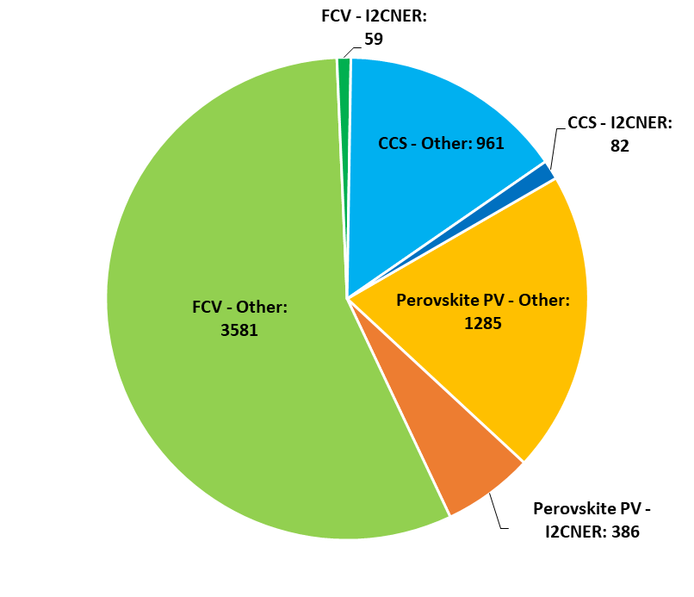

***Figure: I2CNER and Industry Technological Contribution to GDP in 2050***

***(Billions of Japanese Yen)***

# Section 4 – Social and Academic Impacts

## I2CNER’s Impact on Social and Academic Outcomes

Building on the economic and environmental impacts engendered by I2CNER’s efforts, positive social and academic outcomes are also anticipated. As we transition toward a low-carbon society the nature and distribution of these benefits is also of importance to our research and how we focus our efforts in order to maximize these benefits in a fair way.

## Social Indicators impacted by I2CNER Technologies

Within the Energy Analysis Division of I2CNER, along with the environmental and economic aspects of a low carbon society, the social aspects are also analyzed to determine the impacts of the transition. This work includes direct engagement with the public to understand current and future behaviors, preferences and propensity to engage and participate in the energy system.

As we aim for a sustainable transition to the future-low carbon society, all three aspects of sustainability play a role in our analysis – the environment, economy and society – all the aspects are linked, and impact upon each other. As discussed in the economic impacts chapter, one such factor is employment – in terms of the economy, a strong employment sector is critical, however in social terms, employment is also an important indicator, in terms of the types of jobs created, lost, and how these are allocated. Ideally, a sustainable energy society will provide strong employment opportunities across the spectrum of skill sets and income levels, and also provide re-skilling opportunities for those whose jobs become redundant as the energy transition proceeds.

Environmental improvement also affects different people in different ways. The reduction of CO2 is relatively easy to imagine, and usually occurs in a fair manner in the short term. It is logical to say that for every reduction in CO2 that our technologies achieve, that society will benefit in relatively equal terms. However, for different energy system related pollutants, this is not always the case. A good example is particulate matter, often referred to as PM2.5. The reduction of this pollutant, through the shift away from fossil fuel, toward renewable based generation tends to favor people in lower income groups, who are often unable to choose more expensive housing, usually located away from undesirable locales which include power generation facilities.

Another key factor which impacts upon our social energy system analysis is energy policy implementation and change over time. A recent example of renewable energy policy is the Feed-in Tariff (FiT), which pays households for the generation of electricity from their solar panels. This policy can help to rapidly increase the amount of solar generation in the grid, and also reduces solar system pricing over time. However, from a social point of view, only those who own their own home, and with sufficient financial means can participate in such a policy. This has ramifications on the fair distribution of subsidies, participation and energy pricing for all consumers.

The social factors discussed above (employment, environmental improvement, pollutant reduction, subsidy allocation, energy tariffs and participation) are analyzed within I2CNER, both individually to identify progress, and also in a combined manner to help us understand the overall impact of the energy system on society, in terms of fairness and sustainability. When analyzing these factors, our role is to also understand the interaction of these impacts, and to determine which energy system factors most heavily impact upon social outcomes.

## Education and Cultural Exchange

Cultural exchange may be the most complex metric of success for the I2CNER program, because, being an inherently social process that cannot be rushed or fabricated, it is somewhat difficult to quantify. However, given the depth of I2CNER’s trans-Pacific interactions over the past 8 years, it is safe to say that as a group, the Institute has achieved cultural exchange to an impressive degree.

In order to achieve any level of cultural exchange, the most important step is to move people into a new culture. It is undeniable that I2CNER has done just that—in 8 years, Illinois faculty and researchers have made more than 100 trips to Kyushu University, and KU faculty have made more than 75 trips to Illinois. A number of high-level administrators from both KU (6) and Illinois (6) have crossed the Pacific to formalize this exchange on an institutional level. With the understanding that cultural exchange must be embedded in the very framework of the Institute, I2CNER staff at Illinois have made more than 25 trips to Japan over the years, and I2CNER staff at Kyushu have visited the US about 40 times. Finally, Illinois graduate students have made more than 20 trips (about 3 per year on average) to Kyushu, and to date, a total of 11 American undergraduates have done summer internships at Kyushu University. Likewise, 23 KU students so far have participated in our undergraduate research exchange program at Illinois.

Perhaps the richest examples of cultural exchange come from our graduate and undergraduate students because of the intensely immersive nature of their trips abroad. The 11 above-mentioned American undergraduates who completed summer internships at Kyushu had opportunities to: become deeply immersed in the KU research culture, specifically in the culture of the host laboratories; give presentations about their ongoing research projects; forge friendships with Japanese undergraduate students who previously visited Illinois; visit a local museum and participate in Hakata doll painting; experience a Japanese tea ceremony; and take field trips to Nagasaki or Hiroshima. Similarly, the 23 KU undergraduates who visited Illinois were able to: become deeply immersed in the Illinois research culture, specifically in the culture of their host research group; socialize with Illinois undergraduate students majoring in East Asian and Pacific studies (non-engineering students); tour local engineering-related companies; take self-led trips to Chicago to get the US metropolitan experience; give final presentations on their research accomplishments at Illinois; and create a documentary film of their trip to the States. As a direct result of his trip to Illinois in Spring 2017, one of our KU undergraduate students is currently writing a paper with his Illinois Satellite faculty supervisor, Prof. Ertekin.

Outside of our undergraduate exchange programs, the cultural exchange begins to take on a life of its own because as the complexity of the research increases, so does the complexity and frequency of the interactions between the researchers. For example, several of our Illinois graduate students are repeat-visitors to Kyushu, allowing them the chance to experience Japanese culture more completely each time. One graduate student who has visited Kyushu University often through the I2CNER program has admitted, “It is a dream of mine to find a position where I can continue working as a liaison between the US and Japan.” Similarly, several KU researchers who have completed extended stays at Illinois have lasting impressions from their experience. Specifically, a postdoctoral researcher who interacted heavily with our Chemistry faculty expressed his deep appreciation for the critical comments they made about his research and emphasized how valuable that experience has been because it helped him set the future directions for his research.

It is not only students and young researchers who have contributed to cultural exchange at Kyushu and Illinois—senior faculty have been heavily involved as well. As Director of I2CNER, Prof. Petros Sofronis has spent the past 8 years splitting his time 50/50 between the US and Japan, which has positioned him ideally to lead I2CNER’s cultural exchange efforts, particularly amongst our faculty. One of Director Sofronis’ priorities has been to enable and facilitate exchange of academic culture, namely, to bring the collaborative and collegial atmosphere of American research institutions to I2CNER in Japan. Director Sofronis has used a top-down approach, leading by example and making himself readily available to all researchers of the Institute whenever possible. He has also structured I2CNER in a way that benefits young faculty and allows them a degree of independence that is unprecedented in the traditional Japanese university system. By breaking down these traditional barriers, Director Sofronis has created an open atmosphere in I2CNER which fosters innovation and collaboration.

I2CNER’s impact upon cultural exchange is not limited to members of the I2CNER project. Indeed, some of the most notable instances of I2CNER’s impact upon cultural exchange involve parties who have no direct connection to the I2CNER project. One outstanding example is the collaboration that has developed between the librarians at Kyushu University and the University of Illinois. These librarians are working together on ongoing projects and exchanging best practices. In addition, as a result of the exchange between KU’s Executive Vice President for International Affairs and Illinois’ Vice Provost for International Affairs, Illinois hosted a MEXT Long-Term Education Administrator Program (LEAP) intern from Japan so that she could learn about American higher education and international programming.

Though there is undoubtedly much more work to be done to promote cultural exchange between Japan and the US, I2CNER has certainly taken vital steps and planted essential seeds to extend and enrich this fledgling tradition. While the current impact of I2CNER’s efforts cannot be denied, the future progress of this exchange will be most secure in a scenario where I2CNER can remain a steward of the tradition. Cultural exchange is one of the many areas where I2CNER has great potential to add value to Japan, the US, and the world at large by acting as a foundation bridge between two such complex and disparate cultures.

# Section 5 – Energy Security

## How I2CNER Contributes to Energy Security

With the expected changes to the energy system, particularly the shift away from fossil fuels in preference for renewable energy sources, the energy security level in Japan can be improved significantly. Specifically, within I2CNER, the development of Perovskite PV is expected to contribute directly to this critical measure of the success of Japanese renewable energy policy. In addition, several of I2CNER’s technologies are considered as enablers of energy security improvements. These technologies typically enable the storage of intermittent renewables-based generation, indirectly allowing for the further deployment of renewable energy and the improvement of energy security. Examples originating from I2CNER’s technology portfolio are detailed below.

## Technologies Contributing Directly to Energy Security

***Hybrid Organic-Inorganic Perovskite PV***

Perovskite PV cells are being developed in I2CNER, and with projected lower costs, and superior power conversion efficiency when compared to mainstream silicon PV, these cells are expected to dominate the market by 2050. I2CNER’s contribution of superior cells to this market is expected to be approximately 30%, and by 2050 we estimate that solar PV will generate approximately 248TWh of electricity. Solar PV will make a significant contribution to energy security in Japan by 2050, with I2CNER contributing 7.5% toward the approximately 25% energy security envisaged for Solar PV.

## I2CNER Technology Initiatives Contributing to Energy Security

***Energy Carriers and Storage***

I2CNER research within this initiative focuses on electrolysis, both from solid oxide and polymer electrolyte fuel cells (SOFC and PEFC), storage through new battery technologies and carbon neutral energy transport and storage. These technologies each has a role to play in the indirect improvement of energy security. These technologies enable additional deployment of RE, allowing us to store, transport and convert RE into useful forms of energy for multiple applications in the home, industry and for transportation. SOFC and PEFC technologies developed at I2CNER allow for high efficiency, low cost water electrolysis which can take advantage of intermittent RE sources. Further, applying these technologies to our reversible fuel cell/electrolysis cell (FC-EC) the stored intermittent RE based energy can be used more efficiently on-site than selling electricity to the grid, further enhancing the ability for greater RE deployment.

***Hydrogen Economy***

As with the energy carriers and storage initiative, the introduction of a hydrogen economy will likely facilitate additional deployment of RE. The additional RE-based generation can be stored as hydrogen, for use in multiple industries. In order to usher in the hydrogen economy, I2CNER is focusing on enabling technologies, notably new low cost, high strength stainless steels to transport and store hydrogen at ever increasing levels of compression and to enable a reduction in the production cost of hydrogen vehicles and associated infrastructure. In addition, I2CNER works directly with government and industry stakeholders to analyze transport sector design and determine the optimal locations for Japan’s future hydrogen refueling infrastructure. This whole system approach to realizing the hydrogen economy in Japan will also offer opportunities for increased energy security.

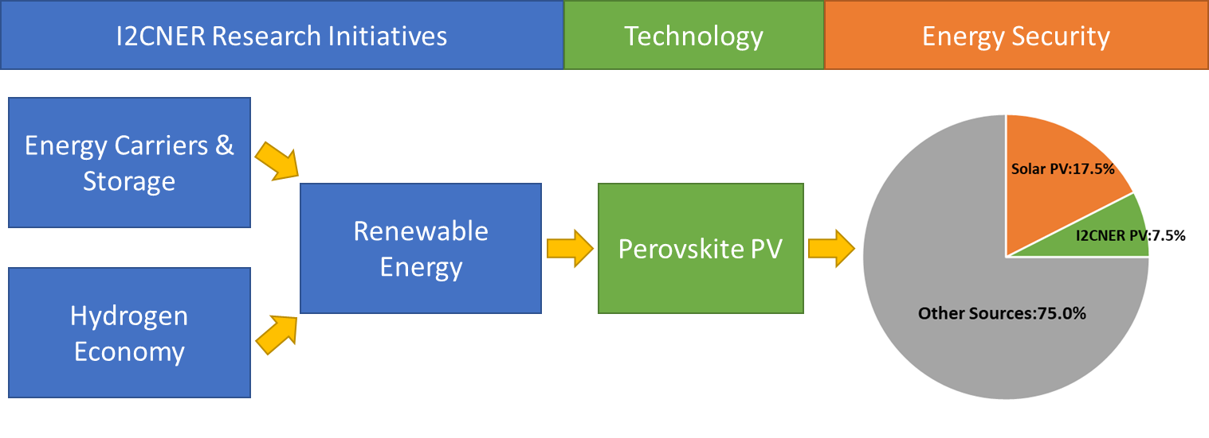 ***Figure: I2CNER’s energy carriers and storage and hydrogen economy research initiatives provide potential for the increased deployment of RE. Mature perovskite PV cells are expected to make up a significant portion of the future market and contribute directly to energy security in 2050.***

# Appendix A. Calculation and Estimation Methodology

## General principles for CO2 impacts estimation

* Deployments and specifications of various energy systems to calculate CO2 emissions in 2050 are derived from I2CNER scenario D (scenario A and hydrogen import). Efficiency and cost parameters of technologies in the scenario rely on Power Generation Cost Analysis Working Group report [1] unless otherwise stated.
* CO2 emission reduction by an energy technologies deployment is allocated per device or as a part of the whole energy system, with I2CNER’s contribution determined by the proportion of avoided CO2 emissions, energy consumption savings, or by portion of the total cost.
* I2CNER’s contribution to the CO2 emission reduction target for 2050 via technology deployment to the energy system is limited to a maximum of 50%, recognizing that technologies deployed to the market cannot be completed without a significant contribution from industry.
* The level of advancement and deployment of the energy system to which I2CNER’s contribution is calculated assumes that I2CNER’s research will successfully progress along I2CNER’s roadmaps, and that the developed technologies will be superior in the market.
* Emission reductions are calculated relative to 1990 levels.

## General principles for CO2 impacts estimation

* Input-Output analysis are conducted to analyze economic impact of technology deployment using the latest version year 2011 of Input-Output Table of Japan assuming a fixed economic structure in the future.
* Impacts analyses include the direct effect, the first indirect effect and the secondary indirect effect.

## Low Cost, high Strength Stainless Steels

* New low-cost H2 compatible stainless steel with an 800MPa yield strength, reducing weight will be used for FCV, H2 infrastructure, power generation and import facilities.
* 195TWh of low carbon H2 from Australian brown coal gasification and CCS will be imported.
* I2CNER’s contribution to the development of this technology is assumed to be １% allocated by the cost of piping against the total infrastructure cost.

## Carbon Neutral Energy Transport and Storage

* Carbon Neutral Energy Transport and Storage will be used to accommodate PV output.
* Round trip efficiency of energy storage will be 50%.
* I2CNER’s contribution to the development of this technology is assumed to be 50%.

## CO2 Separation Membranes

* Membrane CO2 capture technology reduces the energy required for CO2 capture by 2/3 compared to standard chemical absorption CO2 capture technology.
* CCS will deploy for all coal fired, and a portion of gas fired power generation toward 2050.
* Coal fired and gas fired power generation will remain in use and generate power at a similar level to current generation.
* 38 power plants with CCS will be deployed from 2030 to 2050.
* CAPEX to install CCS is 200 billion yen for 750 MW power plant.
* OPEX to run CCS is 15 billion yen per year for 750 MW power plant.

## CO2 Migration Modelling and Monitoring

* I2CNER’s low cost CO2 monitoring technology reduces the cost of CO2 monitoring to 1/10 of conventional seismic monitoring costs.
* The cost of monitoring CO2 storage by conventional seismic technology is 152 yen per t-CO2.
* The contribution of new CO2 monitoring technology to emission reductions by CCS can be allocated through the percentage of cost savings offered (2.4%).

## Organic-Inorganic Hybrid Perovskite Solar Cell

* A large amount of PV will be deployed, generating 248 TWh in 2050 [2].
* Perovskite PV technology will account for 30% of the total PV market.
* Perovskite cells contribution is allocated by the percentage of cost reduction engendered by using new cell technology, as a portion of the total PV system cost (23%).
* The percentage of I2CNER’s contribution to the development of this technology is assumed to be 100% (i.e. I2CNER’s perovskite cell is superior among all perovskite research).
* 202 GW PV will be deployed by 2050.
* Average price of PV is 217 thousand yen per kW.

## Polymer Electrolyte Fuel Cells (PEFC) and FCVs

* Durable, low cost and lower Pt PEFC will be used in FCVs.
* The cost of Pt for a current generation FCV is 90000 yen [8].
* I2CNER’s electrode reduces the amount of Pt used in a fuel cell by 90%.
* FCV will replace all new automobiles except for the Kei-car in 2050.
* PEFCs will be used for household hot water supply in place of town or LP gas.
* It is assumed that 15million FCVs will be used in 2050 and 37 billion yen will be payed to purchase FCVs.
* The life time of an FCV is 11 years.